MHF4U UNIT TEST 1 – POLYNOMIAL AND RATIONAL FUNCTIONS.
Overall Expectations :
1. identify and describe some key features of polynomial functions, and make connections between the
numeric, graphical, and algebraic representations of polynomial functions;
2. identify and describe some key features of the graphs of rational functions, and represent rational
functions graphically;
3. solve problems involving polynomial and simple rational equations graphically and algebraically;
4. demonstrate an understanding of solving polynomial and simple rational inequalities.
Knowledge
- Use factorising to graph the polynomial f(x)= x⁴ - x³ - 7x² + x + 6. Show all intercepts.

- Solve the inequality algebraically : -4x² – 4 < - 90

- Suggest a possible equation for the function below.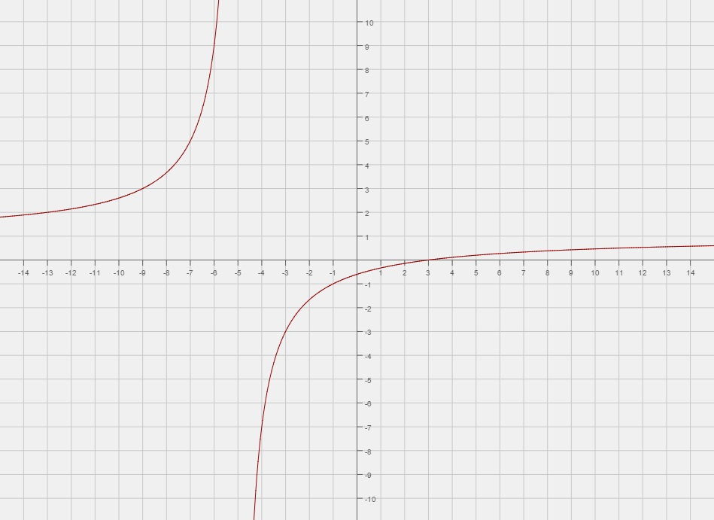

- Determine if f(x) = x² -4 is odd, even, or neither.

- Describe the domain, range, and end behaviour of f(x) =

Thinking /Inquiry
- Explain why solving the denominator in the rational function will find you the vertical asymptote. [ 3 ]

- Why does a result of f (x ) = 0 derive a factor of a polynomial ?

- How do you know f(x) = 2x² - 2 and g(x) = -3 (x +1 ) ( x – 1 ) are in the same family ?

Communication

- Sketch the rational function f(x) = ( 3 – x )/ (2x – 3)

- Show graphically the regions that are defined by f(x) < 0 if f(x) = x³ +2x² –x-2

- Graph the rational function f(x) = ( x² - 3x – 10)/ 2x - 10 ) and show the discontinuity.

Application
- A projectiles flight is mapped with the equation h = - 2t² +19t + 2. Calculate :
- The average rate of change between 1 and 2 seconds.
- The instantaneous rate of change at 1 second.

- The volume of a box is given with the equation V = 4x³ -44x² + 120. Calculate :
- The dimensions of the box if volume is to be maximised.
- The length and width, if height = x.

- An average profit function is mapped with AP(x) = [ R(x) – C(x) ]/ x
If R(x) = 2x² + 3x + 1 and C (x) = x ² + x + 0.5

Derive a rational function for AP(x)

