MHF4U Practice Exam
Knowledge / 32

- Convert 250 degrees to radians. [ 2 ]

- Calculate the arc length on a circle that has radius 8 cm and arc subtended by an angle of 3 radians. [ 2 ]

- Calculate an exact ratio for Sin 330° [ 2]

- Comment on the characteristics and end behavior of the function y = - x³- 3x² – 1 [ 4 ]

- If f(x) = x – 4 and g (x) = x² – 6 then calculate

- F(g(x) ) [ 3 ]

- G(f(x)) [ 3 ]

- Calculate the remainder when f(x) = x⁴- x² – 3x – 8 is divided by ( x - 3) [ 3 ]

- If f( x ) = 3x – 1 , write an expression for the inverse function. [ 3 ]

- Calculate the roots of the equation and check for extraneous solutions :
log ( 5 + x ) = 3 [ 4 ]

- Rewrite 2³ = 8 in log form. [ 2 ]

- From the graph below, suggest a possible function. [ 4 ]

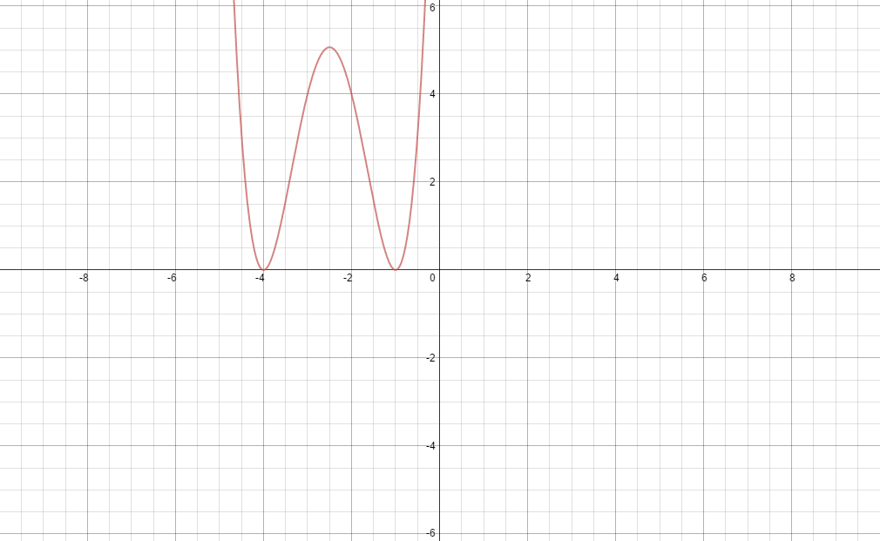
Communication / 27

- If f(x) = 1/x then sketch -2 ( f ( x + 4 ) – 5 [ 5 ]

- Graph and describe the regions defined by the inequality f(x) < 0 if f(x) = x² -5x – 14
[ 5 ]

- Graph the rational function f(x) = (2x + 4 ) / (x – 7 ) and show intercepts and asymptotes. [ 4 ]

- If f(x) = x ² - 5 x – 24 and g(x) = x – 8 show the region defined by f(x) > g (x) [ 5 ]

- Sketch –f(x) – 4 if f(x) = sinx [ 4 ]

- Sketch the graphs of sinx and cosx and show where cosx = sinx. [ 4 ]

Application / 28

- An investment of 3000 dollars is invested for 7 years and grows to 4000 dollars.
What was the annual interest rate ? ( interest was compounded monthly ) [ 3 ]

- If a substance has a concentration of hydronium ions of 0.000004 M/L , what is its pH ? [ 3 ]

- The flight of a projectile is modelled with the equation h = - 0.9t² + 20t + 0.8.

Calculate the :

- Average rate of change from 1 to 4 seconds. [ 3 ]
- Instantaneous rate of change at 2.5 seconds. [ 3 ]

- The rotation of a wheel is modelled with a sinusoidal function. The wheel has a radius of 4 cm and completes a revolution every 5 seconds. If the edge of the wheel has a marker,

i) Model the path of this marker over a minute with a graph. [ 4 ]

- Derive the equation of the sinusoidal function. [ 3 ]

III) Use your equation to calculate height of the marker at 10 seconds. [ 2 ]

- From the data below,

- Suggest a possible function for modelling. [ 3 ]
- Estimate population in 2020. [ 2 ]
- What limitations might be there in using such a formula ? [ 2 ]

Year | Population
2013 | 100,000
2014 | 107,000
2015 | 114, 490
2020 | ………..

Inquiry / 24

- Use a unit circle or otherwise to prove that tanx = sinx / cosx for ALL values of x ). [ 4 ]

- Prove that the rational function y = ( x² – 4 ) / ( x – 2 ) has a discontinuity. [ 3 ]

- Explain where the graph of secx has asymptotes and why [ 4 ]

- Why does the trigonometric equation cos x = -2 have no solutions ? [ 2 ]

- Graph the rational function y = ( x - 1 ) / ( x + 3 ) and explain the behavior of the range and domain . [5 ]

- Why is the range of e^x > 0 ? [ 3 ]

- Is the graph below an odd or even function ? How do you know ? [ 3 ]

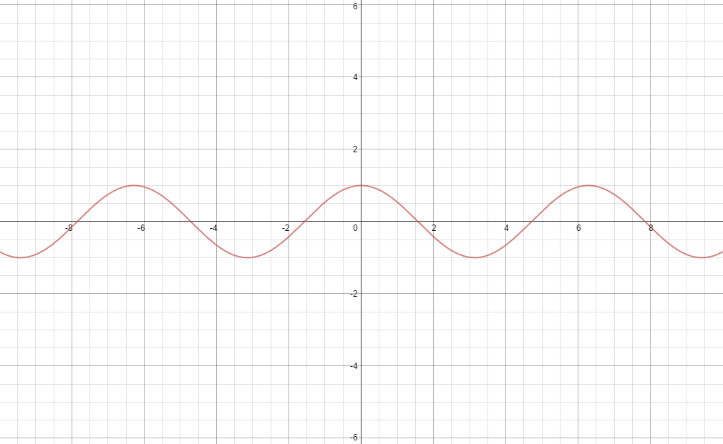

END

